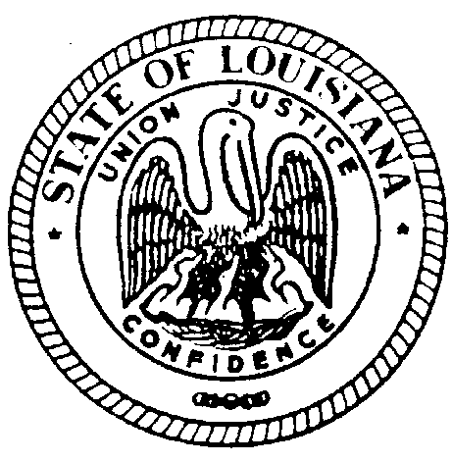

State of Louisiana

Board of Examiners for Sanitarians

7515 Jefferson Hwy., #161

Baton Rouge, LA 70806

Meeting notices for the LA State Board of Examiners for Sanitarians are posted on our website at www.lsbes.org .

